|  |  |
| --- | --- |
| Logo_FPT_University_doc | **MINISTRY OF EDUCATION AND TRAINING** |

**FPT UNIVERSITY**

**CAPSTONE PROJECT DOCUMENT**

**UJD\_VN**

Report #1 – Project Introduction

|  |  |
| --- | --- |
| **Useful Japanese Dictionary for Vietnamese** | |
| **Group Member** | SE02316 - Lê Đình Nam |
| SE02300 - Phạm Thị Minh |
| SE02189 - Nguyễn Ngọc Tuấn |
| SE02336 - Phạm Tiến Đạt |
| **Supervisor** | Mr. Nguyễn Văn Sang |
| **Project Code** | **UJD\_VN** |

- Hanoi, 05/2014 -

Table of Contents

[1 INTRODUCTION 3](#_Toc389745362)

[1.1 Purpose 3](#_Toc389745363)

[1.2 Acronyms and Definitions 3](#_Toc389745364)

[2 ABSTRACT 3](#_Toc389745365)

[3 LITERATURE REVIEW 3](#_Toc389745366)

[4 PROPOSAL 6](#_Toc389745367)

[4.1 The idea 6](#_Toc389745368)

[4.2 Objectives 6](#_Toc389745369)

[4.3 Brief description about system 7](#_Toc389745370)

[4.4 System features 7](#_Toc389745371)

[5 BENEFIT FROM PROJECT 8](#_Toc389745372)

[5.1 For our group 8](#_Toc389745373)

[5.2 For Community 9](#_Toc389745374)

[6 CRITICAL ASSUMPTION AND CONSTRAINTS 9](#_Toc389745375)

[7 POTENTIAL RISKS 9](#_Toc389745376)

[8 REFERENCES 10](#_Toc389745377)

# INTRODUCTION

## Purpose

This document is created as the introduction for project Useful Japanese Dictionary for Vietnamese – our Capstone Project at FPT University. In this document, we will descript the overview of some existing systems, the initial idea for our project, a brief description about our expected system and some potential risks, critical assumptions, constrains. Moreover, this document also shows opportunities what it offers for users.

## Acronyms and Definitions

|  |  |
| --- | --- |
| **Acronym & Abbreviation** | **Definition** |
| UJD\_VN | Useful Japanese Dictionary for Vietnamese |
| FU | FPT University |
| UJD | Useful Japanese Dictionary |
| Q&A | Question and Answer |
| JLPT | Japanese Language ProficiencyTest |
|  |  |
|  |  |

**Table 1-1:** Definitions and Acronyms

# ABSTRACT

In Viet Nam, Information Technology are strongly growing and Japan is the largest market. People who want to learn Japanese to work for Japan also increase more. Thus Japanese training center were opened very much. But not everyone can enough time to learn Japanese at training center. So website and application which can help people learn Japanese was created. By this way, people can learn online at their house with lower cost. Although website learn Japanese have lots but following survey of people who used website, they see some website have too much Kanji, other websites have too few examples for new word, or have to upgrade to use more, etc... It makes user dissatisfaction. With the aim of helping user learn Japanese easy and full way, the website is expected to sold this limit and add some other features to fit desiderate of user. Our website were created to solve this problem.

# LITERATURE REVIEW

Japan is know that the country has information technology very development. And have a lot of software engineers want to work in Japan. So, website and application were created a lots to help them study Japanese. Moreover Japanese is used in Vietnam very much. However still have not website or application which really perfect to help user. For example: nhgo.net, lophoctiengnhat.com, romajidesu.com…

**Nhgo.net:**

This website allows user search dictionary, kanji, grammar and post question. General, website is easy to use and search knowledge.

*Advantages:*

* Search with more option, it help user find expected result
* Kanji and grammar quite full
* Forum to post question, any member can comment to help each other

*Disadvantages:*

* Do not support search dictionary Viet – Nhat
* More words do not have mean with Vietnamese
* Example sentences do not have mean with Vietnamese
* Do not support listening, reading, conservation
* Support for JLPT not full

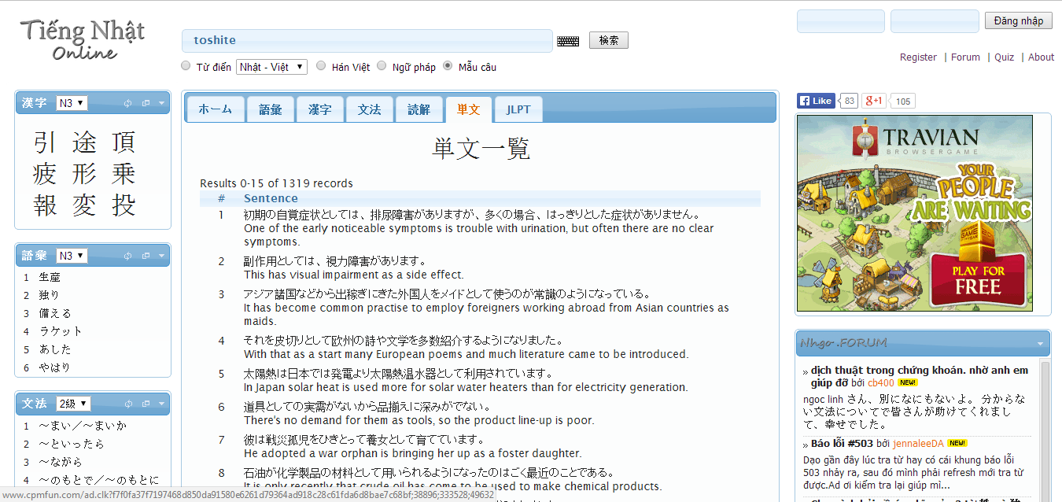

**Figure 1-1:** nhgo.net interface

Have a lot of words and example sentences do not mean with Vietnamese, it can make beginner hard to use or other users misunderstand. Website support very much option search but have not for Viet – Nhat, it will make user feel inconvenience.

**Lophoctiengnhat.com:**

This website is not free, user have to log in to use resources, may be user have to upgrade account to study more. General, website help user learn JLPT with full listening, reading. It also support search.

*Advantages:*

* Support study JLPT full with level
* Support search

*Disadvantages:*

* User have to register, upgrade account
* Do not support more option for search, only search dictionary likes normal way

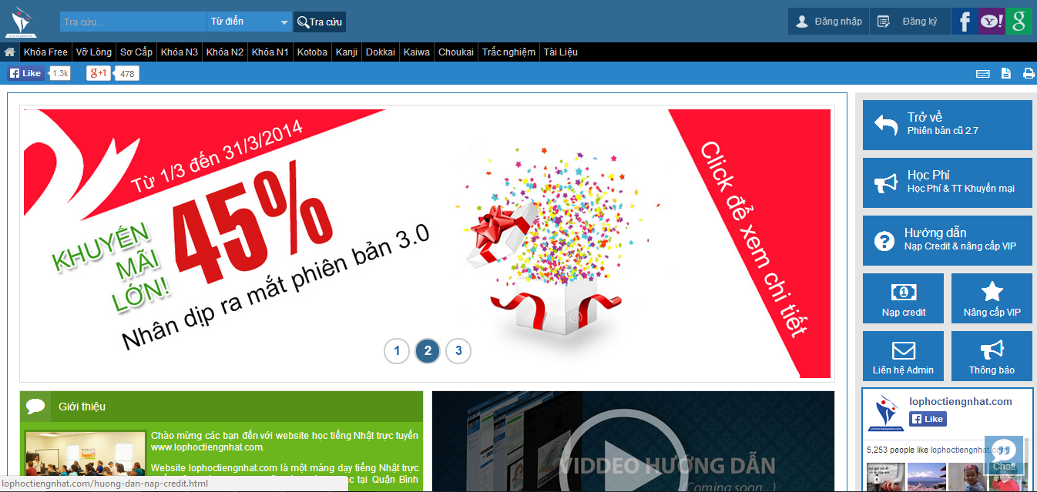

**Figure 1-2:** lophoctiengnhat.com interface

Because this is website of center, it will provide quite full document to user register and upgrade account to study. But if you do not register and upgrade, you can study more lesson. Moreover, search function is too simple, it can help user more while learning.

**Romajidesu.com:**

In overview, this website have main function is search. Converting romaji to katakana or hiragana for beginner.

*Advantages:*

* Search kanji with more result and example sentences
* Search dictionary
* Search lookup with how to write kanji

*Disadvantages:*

* Do not support more language, only Japanese – English
* Result search by English
* Search do not have more option

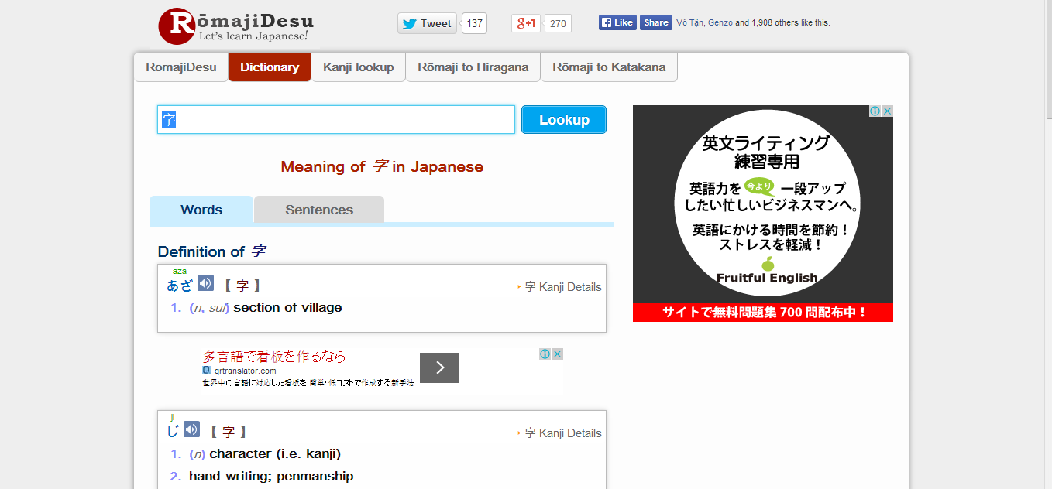

**Figure 1-3**: romajidesu.com interface

This website display by English, it is hard to user who do not know English, special beginner. Moreover it is not support test, JLPT. So users cannot study more such as listening, reading…

# PROPOSAL

## The idea

Nowadays, there are many dictionaries which support Japanese. That can be a website or mobile application. All of them have been created for the purpose of helping users search vocabulary or studying Japanese more easily. But we found some disadvantages which existing in website which support users studying Japanese. So, our project – UJD\_VN will include some main functions of existing dictionary website and add some special features such as showing examples by Vietnamese, supporting searching specialized vocabulary or users can contribute idea, good knowledge to make our database become larger. Moreover, we will provide freely website to users. Here, we toward provide website for Vietnamese who want to studying Japanese communication or who want to join Japanese certification exams.

## Objectives

This project is the Capstone Project in FPT University studying program. The first, this project is responsibility for all team member. So we must complete all requirements from teacher and FU. During the time doing project, we can learn how to develop a project, how to manage project, how to communicate better between team member, how to control time, how to perform teamwork effectively. Moreover, we also have experience about PHP, website design, test website… Therefore, we think this project is very necessary for us to improve skills, knowledge which we studied in FU. This project also make our CV more beautiful after graduating from FU. This is also an opportunity for us to prove capacity with recruiters.

The second, because we are in JS course. In studying’s progress, we realize some disadvantages of studying Japanese for Vietnamese. So we want to help users, especially Vietnamese users, to improve capacity Japanese of them, help them can communicate better with Japanese. The highlights of us are interface friendly, useful functions. Specially, website display completely in Vietnamese, so users can use functions easily, even though they do not know English.

## Brief description about system

This software is a web application. With friendly and simple interface, users can easily find out what they want without registration. This web help users to better understand about vocabulary, grammar, kanji, display the appropriate vocabulary and provide the other vocabulary have same meaning. Therefore, users can reference to make the best choice for themselves. It also help users review about skill reading, writing, speaking, listening. In addition, with a lot of exercise and small test, users can accurately assess their own capacity. And user also can send opinion to admin if there is anything that needs to be modified.

UJD uses familiar technologies as: JavaScript, PHP… It is support operating systems such as windows and current browsers as Firefox 20, Chrome 25 or above.

## System features

About the features of UJD, we focus to provide for users main features as searching, doing test, listening conversation, reading document, contributing good opinions. Moreover, admin can manage members, manage database, manage contribute database and manage Q & A. In here, we focus on features which can help users can understand the best way what user want to have with features of UJD. There are the detailed features of UJD:

* **Search**: User can search vocabulary and UJD will display example sentences or conversation, grammar or Japanese video which include vocabulary which user searched. With searching features, user can understand visually, apply easily in communication, and how to use vocabulary in the situations. This is very new point and useful of UJD when compare with other website which also provide user to study Japanese now. User have the following searching option:
* Searching with example sentences: user search a vocabulary and UJD display example sentences which include these vocabulary.
* Searching with conversation: user search a vocabulary and UJD display example conversation which include these vocabulary.
* Searching with grammar: user can search grammar of N2, N3, N4, N5. UJD will explain these grammar and give to user example about these grammar.
* Searching Japanese video: user can search Japanese video.
* Searching specialized Japanese: user can search specialized Japanese in many fields as IT, economic, mechanical, traffic, financial …
* **Contributing opinion**: User can contribute opinion about UJD website or contribute database as good sentences, good conversation, good video by using contributing feature. Admin of UJD will approve correctness and add to database. This is feature which will help us make a larger database for system.
* **Listening conversation**: User can improve ability listening by listening available conversation on UJD. Listening database of us is very diversity from everyday conversations, common conversational to conversations in a realistic situation. Especially, we provide conversations from elementary to intermediate for user can train to join Japanese certification exams.
* **Reading document**: User can find available Japanese document in UJD as elementary grammar, intermediate grammar, list kanji, readings, Minnano Nihongo lesson.
* **Doing test**: User can do tests at N2, N3, N4, N5 level. Then UJD will scored for user. This is an important feature of UJD. We want to help users toward Japanese certification exams.
* **Login/Logout**: User can login to use more features of UJD. User can register an account to login or login by using Facebook, Google account.
* **Changing password/Forgetting password**: User can change new password or require new password if user forgot current password.
* **Managing account**: Registered user can add, edit information or track mark.
* **Managing member**: Admin can view list members, ban or unban member, delete member.
* **Managing contribute database**: Admin can approve opinion of member or delete opinion.
* **Managing Q & A**: Admin can view, reply, delete Q & A.
* **Managing Data**: Admin can add, update, delete data of UJD.

# BENEFIT FROM PROJECT

## For our group

After developing and implementing this project, our group will get some benefits:

● We have more experiences of managing a software project: how to manage plan, time, member and risk.

● Have more knowledge and skill about PHP programming

● Know how to communicate with team members and how to teamwork more effective

● Have more knowledge in Japan and improve Japanese proficiency

● If this application is developed, we will get a good mark in Capstone Project. It makes our grade better.

## For Community

Just need to have a device that connect to the internet and any web browser, user can:

● Easy search for vocabulary, specialized vocabulary, kanji

● Practice the skills: listening, reading, writing, speaking Japanese

● Review the grammar, vocabulary, kanji

● Do exam test N5, N4, N3, N2 and check point

● Users do not need to pay money for using. It is completely free for all users.

# CRITICAL ASSUMPTION AND CONSTRAINTS

We realize some critical assumption after analyzing this project. The first, that is about our team. We assumed that all developer can train PHP in a short time. Before starting this project, nobody in our team have knowledge about PHP, but with programming techniques which we studied at FU, we have to try the best to not missing any deadline in project plan. Besides that, we also assumed that all member in team have a good healthy to do their tasks.

We also have some constraints in progress. The first, about the time and deadline, we must complete task on time. We do not have more time for us to complete developing and deliver application to teachers. Besides, we have to submit report documents before deadline to teacher can review. The second, that is about the quality. Our website must be run well when users perform main functions in Google Chrome, Firefox, Internet Explorer. Finally, we have problem about techniques. We is not in the high level in PHP. So, with the expected functions which we gave, we will try the best to complete our project successfully.

# POTENTIAL RISKS

After studying about this project, we find out some problem that we may be encountered:

● It is the first time we manage a project like this , we have no experience in exchange information, managing and controlling work so we may be miss the deadline or out of scope

● We have not much knowledge in the framework and technique of PHP and web. Therefore, we have to study all of them from the beginning. This work takes a lot of times. The project team may face with the difficult technical problems that may requires long time to resolve so that causes the project be delayed.

● Knowledge of Japanese is extremely large, we have difficulty in providing sufficient information that users need to understand

● With the short duration - about 15 weeks - we cannot success to all functions and miss the deadline.

● In addition, we also have difficulty in using some tools such as Microsoft Project, Sublime Text, My SQL, Source code managing… Therefore, our work management may be not good.

● Sometime, because of careless, team members can lose data, source code… before uploading to server

# REFERENCES

**[1] nhgo.net**

http://nhgo.net/

**[2] lophoctiengnhat.com**

http://lophoctiengnhat.com/

**[3] romajidesu.com**

http://www.romajidesu.com/